**CHAPTER 1 :**

**INTRODUCTION TO ONLINE MOVIE TICKET BOOKING**

* 1. **OVERVIEW**

The project demonstrates an online movie ticket booking website named “**BOOK ALL SHOWS”.**  The site provides the ease to user and give the comfort of staying at home and booking their tickets in a go and avoiding the headache of sticking in queues for hours. The site provides the user with the precise details about the current and coming soon movies and help them to select the perfect conditions so that they can enjoy the movie to the maximum.

The features of the site goes as follows:

* Login option for both the admin and the members.
* Easy sign up option for new users.
* Password security through encryption.
* Instant Booking is available for any user.
* Now showing option helps the user to go through every details.
* Secure payment channel.
* Update already existing database, keeping in pace the recent associated changes undertaken.
* Making the admin familiar with the members’ details so as to be in regular contact with them.
* Users can get the more info, latest offers, discount info and all through the mails to the e-mail id they have provided.

**1.2 ASP.NET-The platform used**

ASP.NET is a [web application framework](http://en.wikipedia.org/wiki/Web_application_framework) developed and marketed by [Microsoft](http://en.wikipedia.org/wiki/Microsoft) to allow [programmers](http://en.wikipedia.org/wiki/Programmer) to build dynamic [web sites](http://en.wikipedia.org/wiki/Web_site), [web applications](http://en.wikipedia.org/wiki/Web_application) and [web services](http://en.wikipedia.org/wiki/Web_service). It was first released in January 2002 with version 1.0 of the [.NET Framework](http://en.wikipedia.org/wiki/.NET_Framework), and is the successor to Microsoft's [Active Server Pages](http://en.wikipedia.org/wiki/Active_Server_Pages) (ASP) technology.

ASP.NET web pages or webpage, known officially as Web Forms[[8]](http://en.wikipedia.org/wiki/ASP.NET" \l "cite_note-7), are the main building block for application development.[[9]](http://en.wikipedia.org/wiki/ASP.NET#cite_note-macdonald63-8) Web forms are contained in files with an ".aspx" extension; these files typically contain static ([X](http://en.wikipedia.org/wiki/XHTML))[HTML](http://en.wikipedia.org/wiki/HTML" \o "HTML) markup, as well as markup defining server-side Web Controls and User Controls where the developers place all the required static and dynamic content for the web page. Additionally, dynamic code which runs on the server can be placed in a page within a block <% -- dynamic code -- %>, which is similar to other web development technologies such as [PHP](http://en.wikipedia.org/wiki/PHP), [JSP](http://en.wikipedia.org/wiki/JavaServer_Pages), and [ASP](http://en.wikipedia.org/wiki/Active_Server_Pages). With [ASP.NET Framework 2.0](http://en.wikipedia.org/wiki/ASP.NET#Versions), Microsoft introduced a new code-behind model which allows static text to remain on the .aspx page, while dynamic code remains in an .aspx.vb or .aspx.cs or .aspx.fs file (depending on the programming language used).

### User controls

User controls are encapsulations of sections of pages which are registered and used as controls in ASP.NET. User controls are created as ASCX markup files. These files usually contain static ([X](http://en.wikipedia.org/wiki/XHTML))[HTML](http://en.wikipedia.org/wiki/HTML" \o "HTML) markup, as well as markup defining server-side web controls. These are the locations where the developer can place the required static and dynamic content. A user control is compiled when its containing page is requested and is stored in memory for subsequent requests. User controls have their own events which are handled during the life of ASP.NET requests. An event bubbling mechanism provides the ability to pass an event fired by a user control up to its containing page. Unlike an ASP.NET page, a user control cannot be requested independently; one of its containing pages is requested instead.

### Custom controls

Programmers can also build *custom controls* for ASP.NET applications. Unlike user controls, these controls do not have an ASCX markup file, having all their code compiled into a [dynamic link library (DLL)](http://en.wikipedia.org/wiki/Dynamic-link_library) file. Such custom controls can be used across multiple web applications and [Visual Studio](http://en.wikipedia.org/wiki/Microsoft_Visual_Studio) projects.

1.3**ADVANTAGES**

* **Convenience**

Available 24 hours a day, and many consumers have Internet access both at work and at home. Other establishments such as internet cafes and colleges provides access as well. A visit to a ticket counter requires travel, time and extra headache of queues.

* **Information**

Provides the precise information about the latest movies and other interesting happening. It provides all the information about the movie such as the genre, director, cast and crew and other important information.

**CHAPTER 2 :**

**DESIGN AND**

**IMPLEMENTATION**

**2.1 USE CASE DIAGRAM**



ADMIN



USER

**FIG 2.1 USE CASE DIAGRAM**

# 2.2 DATA FLOW DIAGRAM

**USER**

**ADMINISTRATOR**

**MOVIES INFO**

**GUEST**

**USER INFO**

**ORDER DETAILS**

**FIG 2.2 DATA FLOW DIAGRAM**

**2.3 SCREENSHOTS**

LOGIN PAGE :

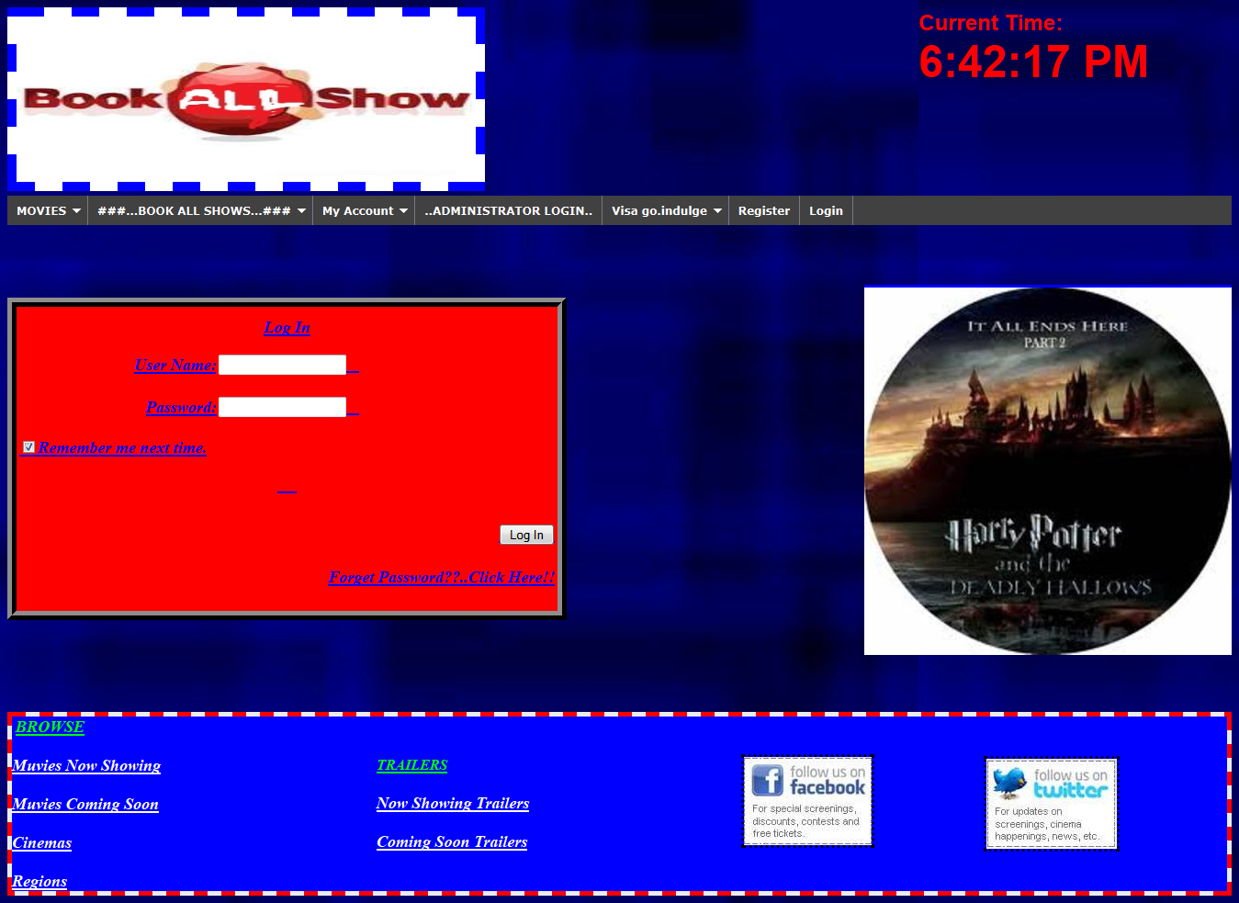

REGISTER:

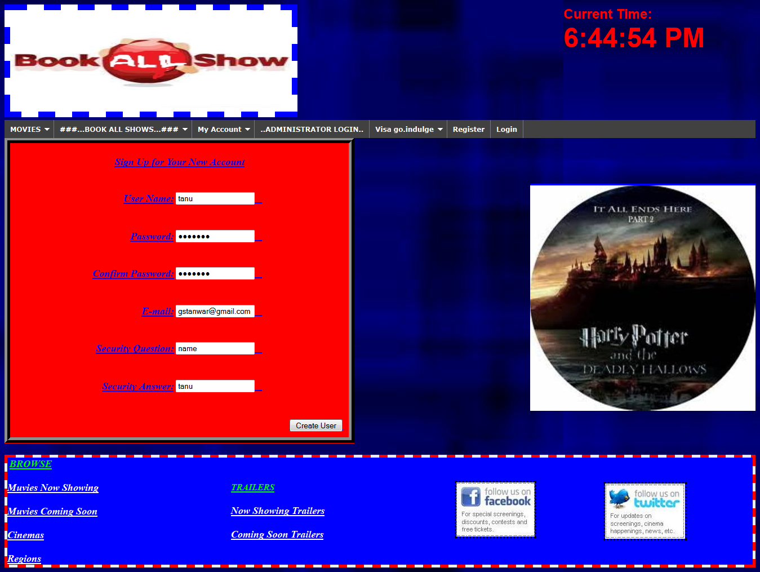

WELCOME PAGE: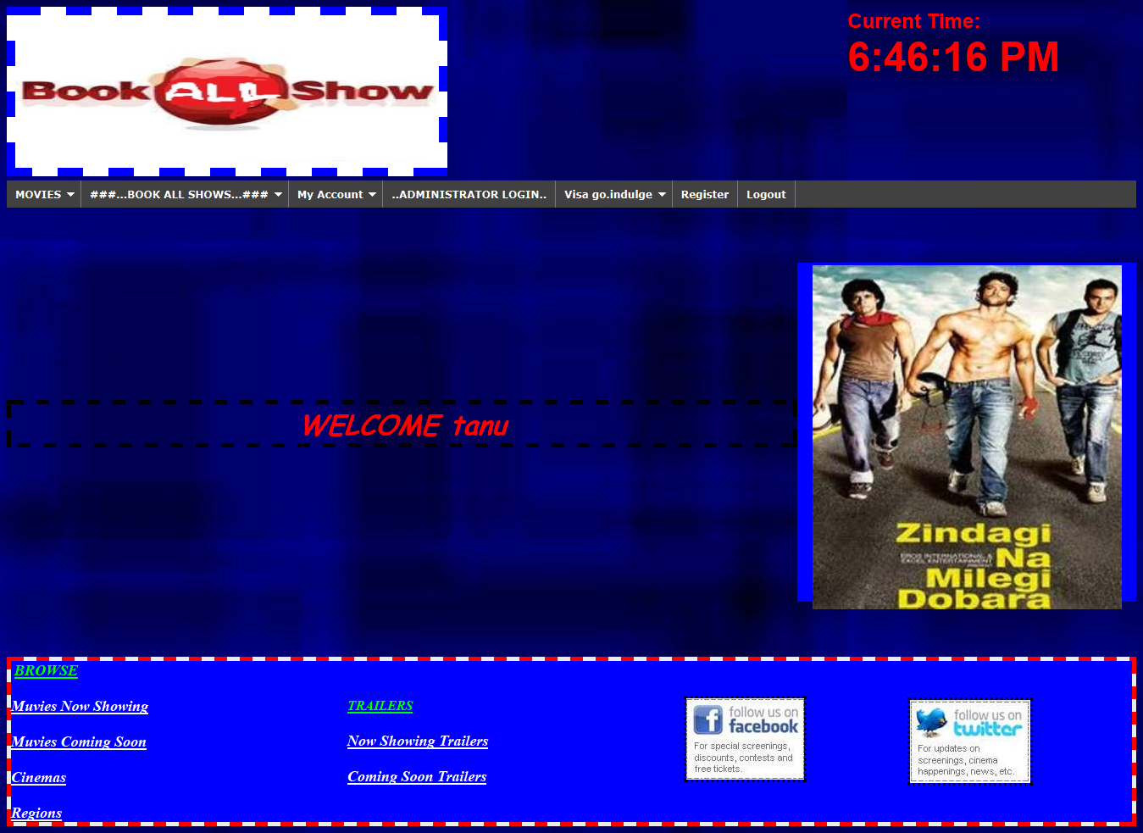

NOW SHOWING MOVIES PAGE: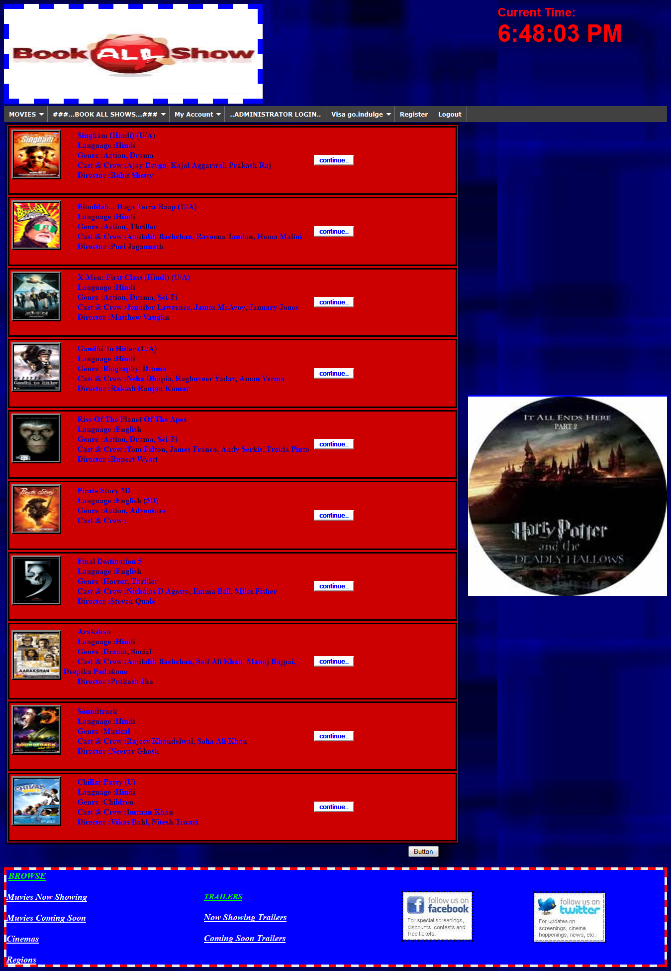

TRAILERS:

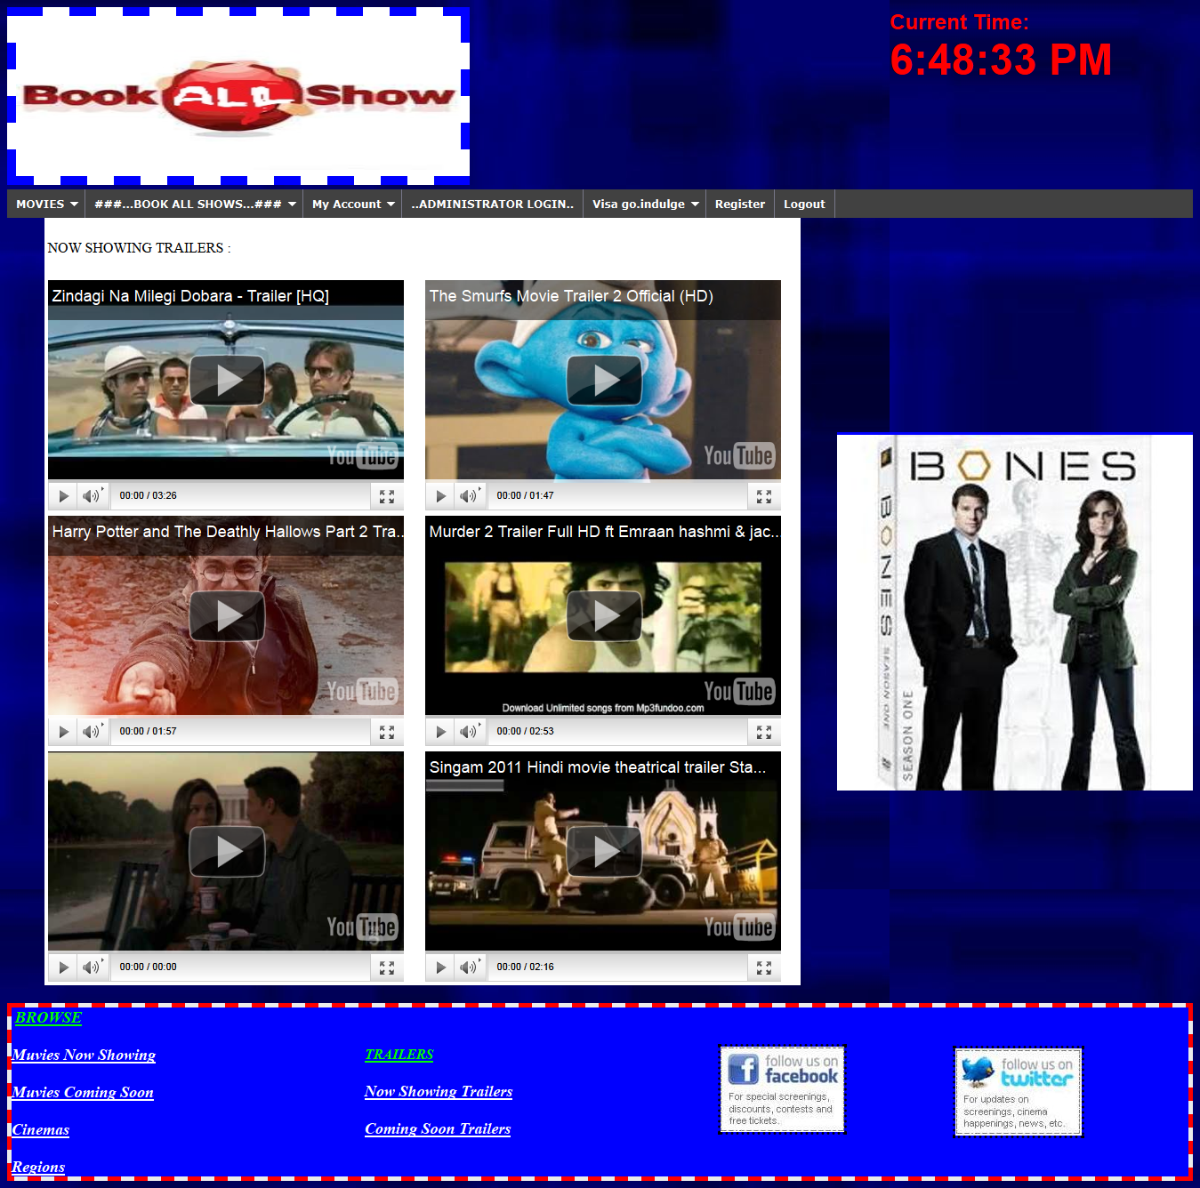

BOOKING PAGE1:

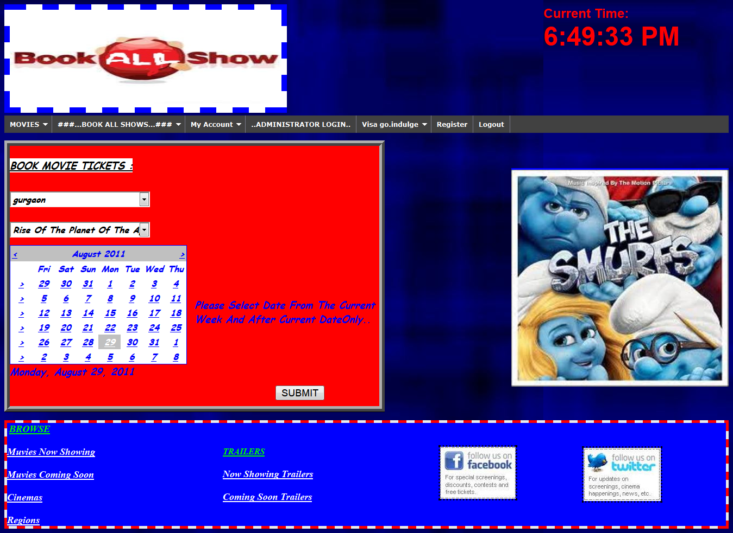

BOOKING PAGE2:

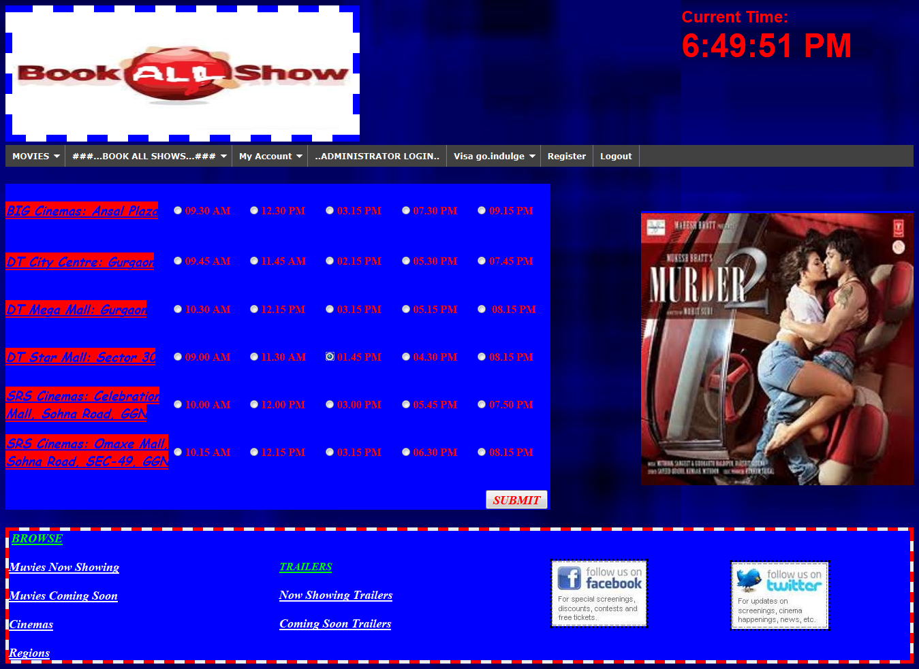

BILL PAGE 1 :

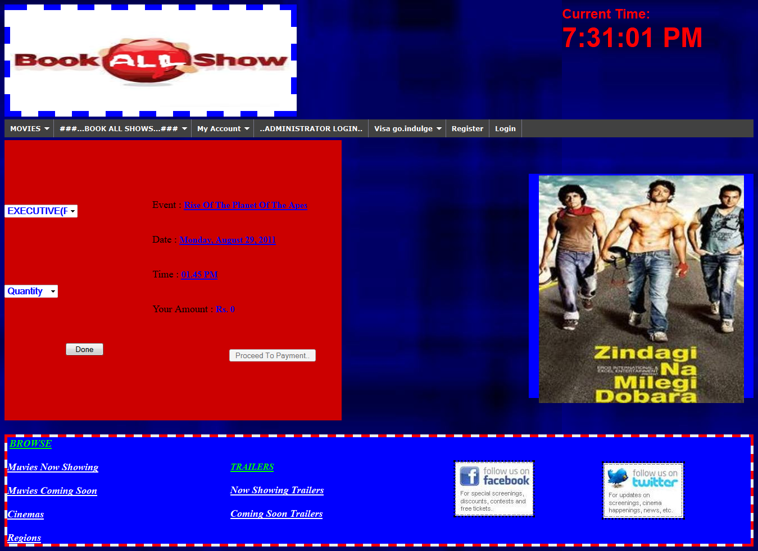

BILL PAGE 2:

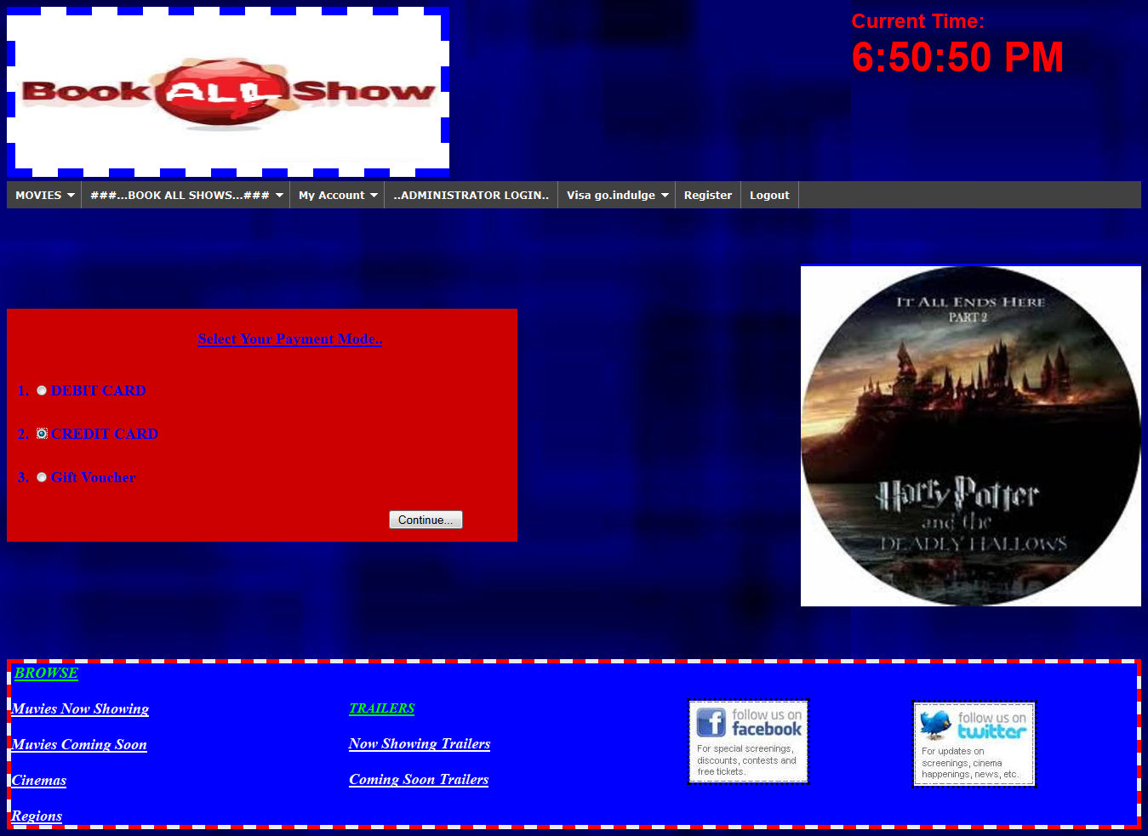

BILL PAGE 3:

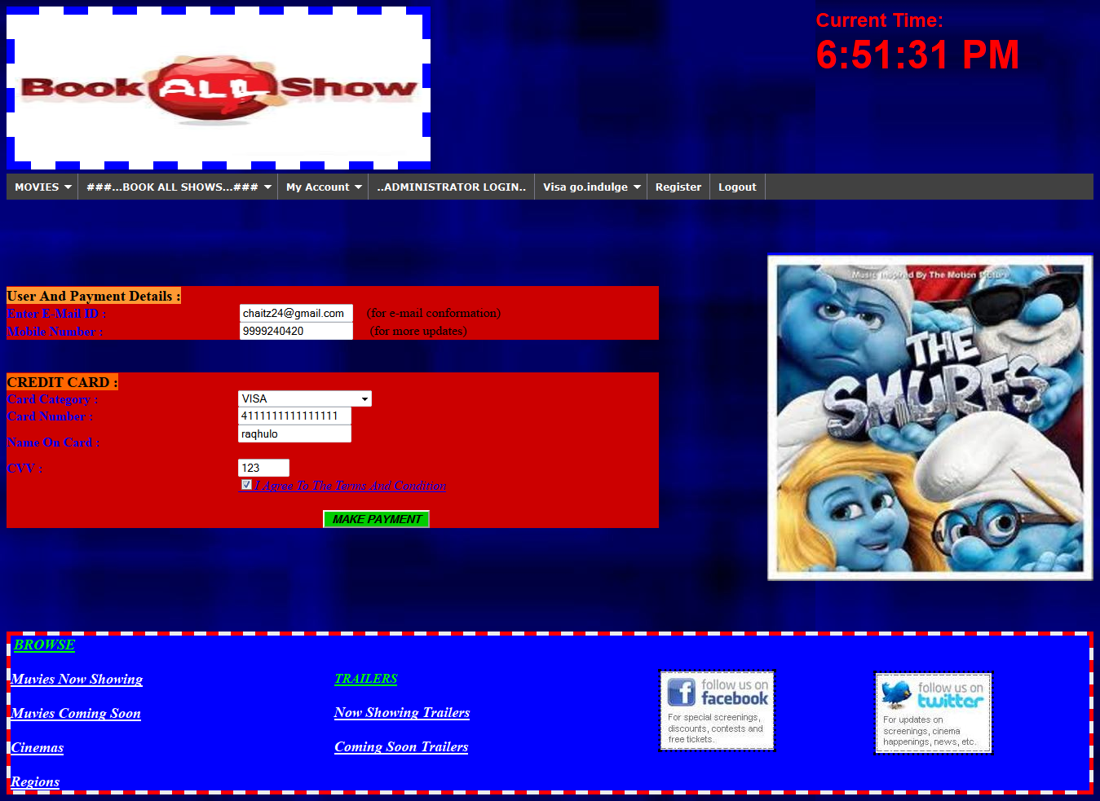

PAYEMENT SLIP PAGE :

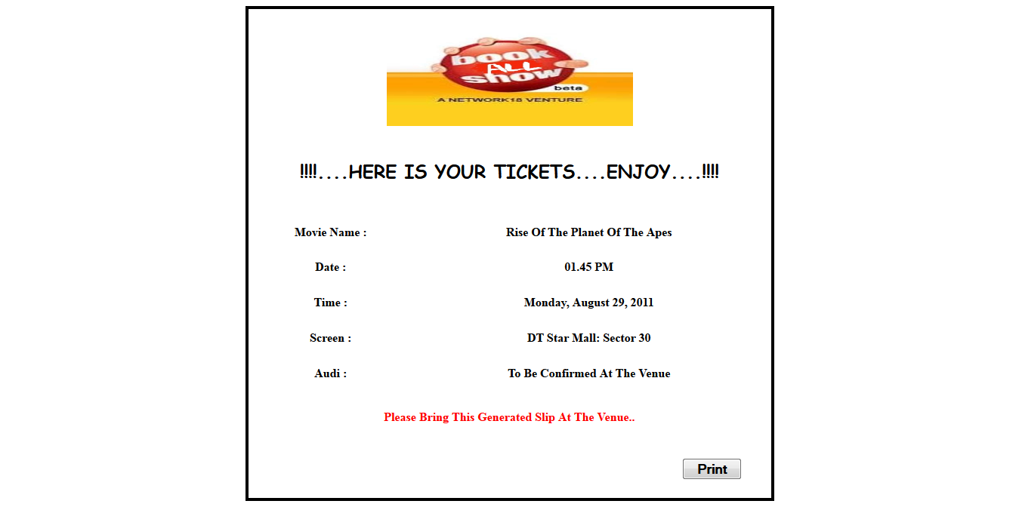

ADMIN LOGIN PAGE :

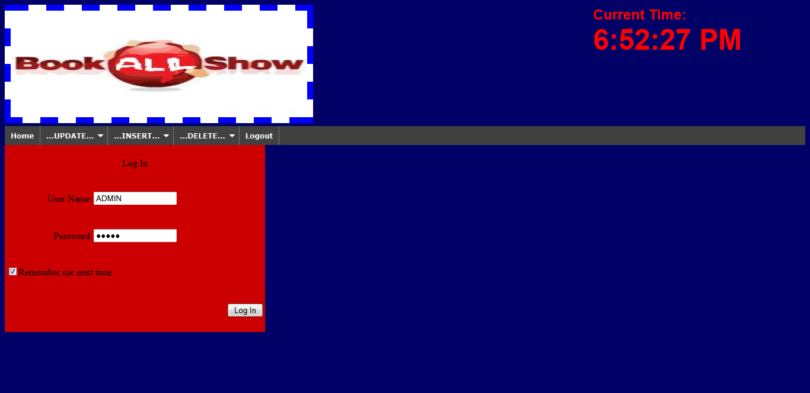

ADMIN UPDATING PAGE :

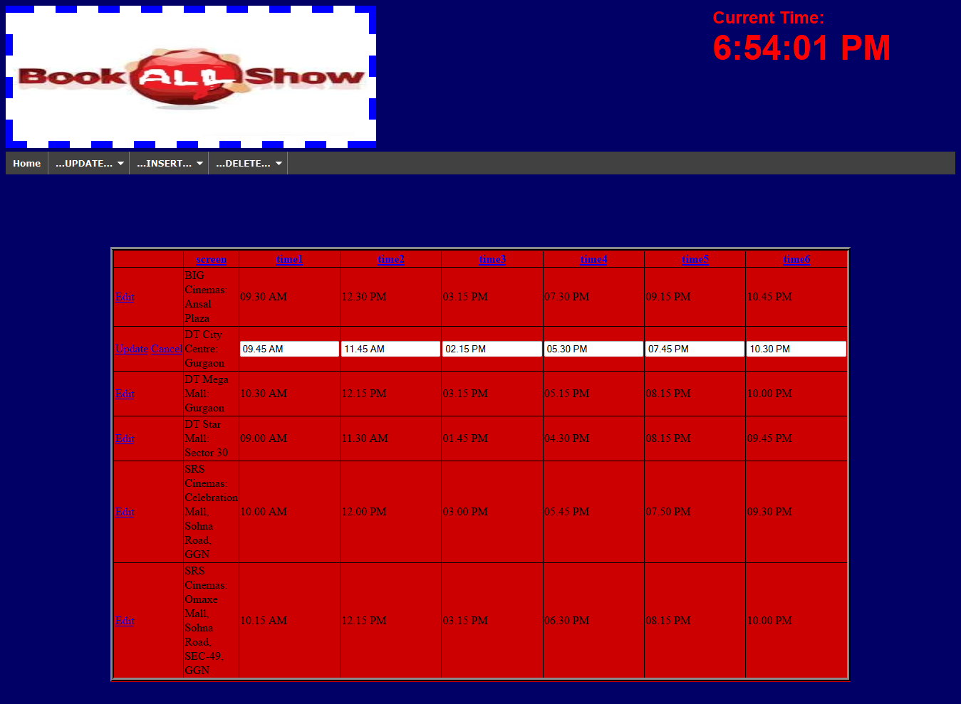

2.4 IMPLEMENTATION(CODING)

2.4.1 LOGIN PAGE:

<%@ Page Title="" Language="C#" MasterPageFile="~/MasterPage.master" AutoEventWireup="true" CodeFile="login.aspx.cs" Inherits="Default2" %>

<asp:Content ID="Content1" ContentPlaceHolderID="head" Runat="Server">

<style type="text/css">

.style7

{

height: 48px;

}

</style>

</asp:Content>

<asp:Content ID="Content2" ContentPlaceHolderID="ContentPlaceHolder1" Runat="Server">

<asp:Login ID="Login1" runat="server" BackColor="Red" BorderStyle="Ridge"

BorderWidth="10px" DestinationPageUrl="~/welcome.aspx"

FailureAction="RedirectToLoginPage" Font-Bold="True" Font-Italic="True"

Font-Size="Large" Font-Underline="True" ForeColor="Blue" Height="329px"

RememberMeSet="True" Width="587px" BorderColor="Black">

<LayoutTemplate>

<table cellpadding="1" cellspacing="0" style="border-collapse:collapse;">

<tr>

<td>

<table cellpadding="0" style="height:329px;width:587px;">

<tr>

<td align="center" colspan="2">

Log In</td>

</tr>

<tr>

<td align="right">

<asp:Label ID="UserNameLabel" runat="server" AssociatedControlID="UserName">User Name:</asp:Label>

</td>

<td>

<asp:TextBox ID="UserName" runat="server"></asp:TextBox>

<asp:RequiredFieldValidator ID="UserNameRequired" runat="server"

ControlToValidate="UserName" ErrorMessage="User Name is required."

ToolTip="User Name is required." ValidationGroup="Login1">\*</asp:RequiredFieldValidator>

</td>

</tr>

<tr>

<td align="right" class="style7">

<asp:Label ID="PasswordLabel" runat="server" AssociatedControlID="Password">Password:</asp:Label>

</td>

<td class="style7">

<asp:TextBox ID="Password" runat="server" TextMode="Password"></asp:TextBox>

<asp:RequiredFieldValidator ID="PasswordRequired" runat="server"

ControlToValidate="Password" ErrorMessage="Password is required."

ToolTip="Password is required." ValidationGroup="Login1">\*</asp:RequiredFieldValidator>

</td>

</tr>

<tr>

<td colspan="2">

<asp:CheckBox ID="RememberMe" runat="server" Text="Remember me next time." />

</td>

</tr>

<tr>

<td align="center" colspan="2" style="color:Red;">

<asp:Literal ID="FailureText" runat="server" EnableViewState="False"

Text="&lt;&lt;LOGIN FAIL&gt;&gt;"></asp:Literal>

</td>

</tr>

<tr>

<td align="right" colspan="2">

<asp:Button ID="LoginButton" runat="server" CommandName="Login" Text="Log In"

ValidationGroup="Login1" />

<br />

<br />

<asp:HyperLink ID="HyperLink9" runat="server"

NavigateUrl="~/forgetpassword.aspx">Forget Password??..Click Here!!</asp:HyperLink>

</td>

</tr>

</table>

</td>

</tr>

</table>

</LayoutTemplate>

</asp:Login>

</asp:Content>

2.4.2 NOW SHOWING :

<%@ Page Title="" Language="C#" MasterPageFile="~/MasterPage.master" AutoEventWireup="true" CodeFile="nowshowing.aspx.cs" Inherits="nowshowing" %>

<asp:Content ID="Content1" ContentPlaceHolderID="head" Runat="Server">

<style type="text/css">

.style22

{

width: 907px;

}

</style>

<title></title>

</asp:Content>

<asp:Content ID="Content2" ContentPlaceHolderID="ContentPlaceHolder1" Runat="Server">

<body>

<div>

<table>

<tr>

<td class="style22" style="border-style: solid">

<asp:Repeater ID="Repeater1" runat="server"

DataSourceID="SqlDataSource1" >

<ItemTemplate>

<table bgcolor="#CC0000">

<tr>

<td class="style22" style="border-style:solid">

<table>

<tr>

<td width="90px">

<img src="images/<%#Eval("image") %>" alt="&nbsp;" width="90px" height="90px" style="border: thick ridge #000000" />

&nbsp;&nbsp;&nbsp;&nbsp;&nbsp;&nbsp;&nbsp;&nbsp;&nbsp;&nbsp;&nbsp;&nbsp;

</td>

<td width="500px">

&nbsp;&nbsp;&nbsp;&nbsp;&nbsp;&nbsp;

<asp:Label ID="Labe4" runat="server" Text='<%#Eval("muvi") %>' Font-Bold="True" ForeColor="Blue" Font-Size="Medium"></asp:Label>

<br />

&nbsp;&nbsp;&nbsp;&nbsp;&nbsp;&nbsp;

<asp:Label ID="Labe5" runat="server" Text='<%#Eval("language") %>' Font-Bold="True" Font-Size="Medium" ForeColor="Blue"></asp:Label>

<br />

&nbsp;&nbsp;&nbsp;&nbsp;&nbsp;&nbsp;

<asp:Label ID="Labe6" runat="server" Text='<%#Eval("genre") %>' Font-Bold="True" Font-Size="Medium" ForeColor="Blue"></asp:Label>

<br />

&nbsp;&nbsp;&nbsp;&nbsp;&nbsp;&nbsp;

<asp:Label ID="Label7" runat="server" Text='<%#Eval("cast") %>' Font-Bold="True" Font-Size="Medium" ForeColor="Blue"></asp:Label>

<br />

&nbsp;&nbsp;&nbsp;&nbsp;&nbsp;&nbsp;

<asp:Label ID="Label8" runat="server" Text='<%#Eval("director") %>' Font-Bold="True" Font-Size="Medium" ForeColor="Blue"></asp:Label>

<br />

&nbsp;&nbsp;&nbsp;&nbsp;&nbsp;&nbsp;

</td>

<td>

<asp:Button ID="Button1" runat="server" Text="continue.." Font-Bold="True" Font-Size="Small" ForeColor="Blue" PostBackUrl="~/booking.aspx" BackColor="White" />

</td>

</tr>

</table>

</td>

</tr>

</table>

</ItemTemplate>

</asp:Repeater>

<asp:SqlDataSource ID="SqlDataSource1" runat="server"

ConnectionString="<%$ ConnectionStrings:projectConnectionString6 %>"

SelectCommand="SELECT \* FROM [info]"></asp:SqlDataSource>

</td>

</tr>

</table>

<asp:Button ID="Button2" runat="server" Text="Button" PostBackUrl="~/booking.aspx" />

</div>

</body>

</asp:Content>

2.4.3 TRAILERS

<%@ Page Title="" Language="C#" MasterPageFile="~/MasterPage.master" AutoEventWireup="true" CodeFile="trailers.aspx.cs" Inherits="trailers" %>

<asp:Content ID="Content1" ContentPlaceHolderID="head" Runat="Server">

<style type="text/css">

.style7

{

width: 850px;

background-color: #FFFFFF;

}

</style>

</asp:Content>

<asp:Content ID="Content2" ContentPlaceHolderID="ContentPlaceHolder1" Runat="Server">

<table align="center" cellpadding="2" class="style7">

<tr style="width:20px">

<td colspan="2">

<br />

NOW SHOWING TRAILERS :<br />

<br />

</td>

</tr>

<tr>

<td>

<iframe id="I1" allowfullscreen="" frameborder="0" height="259" name="I1"

src="http://www.youtube.com/embed/LkpoBIseGAc" width="400"></iframe>

</td>

<td>

<iframe id="I2" allowfullscreen="" frameborder="0" height="259" name="I2"

src="http://www.youtube.com/embed/7emiua3X4p4" width="400"></iframe>

</td>

</tr>

<tr>

<td>

<iframe id="I3" allowfullscreen="" frameborder="0" height="259" name="I3"

src="http://www.youtube.com/embed/I\_kDb-pRCds" width="400"></iframe>

</td>

<td>

<iframe id="I4" allowfullscreen="" frameborder="0" height="259" name="I4"

src="http://www.youtube.com/embed/EZkUz\_fFJck" width="400"></iframe>

</td>

</tr>

<tr>

<td>

<iframe id="I5" allowfullscreen="" frameborder="0" height="259" name="I5"

src="http://www.youtube.com/embed/B5lHV0BzQFE" width="400"></iframe>

</td>

<td>

<iframe id="I6" allowfullscreen="" frameborder="0" height="259" name="I6"

src="http://www.youtube.com/embed/\_CIJW6lDNfI" width="400"></iframe>

</td>

</tr>

</table>

</asp:Content>

2.4.4 BOOKING PAGE 1 :

using System;

using System.Collections.Generic;

using System.Linq;

using System.Web;

using System.Web.UI;

using System.Web.UI.WebControls;

using System.Data;

using System.Data.SqlClient;

public partial class booking : System.Web.UI.Page

{

SqlConnection con = new SqlConnection("server=DELL-PC; integrated security=true; database=project");

SqlDataAdapter adap;

DataSet ds;

string query;

static DataRow dr;

protected void Page\_Load(object sender, EventArgs e)

{

query = "select \* from city";

adap = new SqlDataAdapter(query, con);

ds = new DataSet();

adap.Fill(ds);

DropDownList1.DataSource = ds;

DataTable dt = ds.Tables[0];

if (!IsPostBack)

{

foreach (DataRow dr in dt.Rows)

{

DropDownList1.Items.Add(dr[0].ToString());

}

}

query = "select \* from info";

adap = new SqlDataAdapter(query, con);

ds = new DataSet();

adap.Fill(ds);

DropDownList2.DataSource = ds;

dt = ds.Tables[0];

if (!IsPostBack)

{

foreach (DataRow dr in dt.Rows)

{

DropDownList2.Items.Add(dr[0].ToString());

}

}

}

protected void Button1\_Click(object sender, EventArgs e)

{

Session["g"] = DropDownList1.SelectedItem.ToString();

Session["s"] = DropDownList2.SelectedItem.ToString();

Session["date"] = Calendar1.SelectedDate.ToLongDateString().ToString();

Response.Redirect("~/selectmovie.aspx");

}

protected void Calendar1\_SelectionChanged(object sender, EventArgs e)

{

Label5.Text = Calendar1.SelectedDate.ToLongDateString();

}

}

2.4.5 BOOKING PAGE 2 :

using System;

using System.Collections.Generic;

using System.Linq;

using System.Web;

using System.Web.UI;

using System.Web.UI.WebControls;

using System.Data;

using System.Data.SqlClient;

public partial class selectmovie : System.Web.UI.Page

{

SqlConnection con = new SqlConnection("server=DELL-PC; integrated security=true; database=project");

SqlDataAdapter adap;

DataSet ds;

string query;

static DataRow dr;

static int r = 0;

protected void Page\_Load(object sender, EventArgs e)

{

if (Session["g"].ToString() == "delhi")

{

query = "select \* from dscreens";

adap = new SqlDataAdapter(query, con);

ds = new DataSet();

adap.Fill(ds);

DataTable dt = ds.Tables[0];

dr = dt.Rows[0];

Label8.Text = dr[0].ToString();

RadioButton3.Text = dr[1].ToString();

RadioButton4.Text = dr[2].ToString();

RadioButton5.Text = dr[3].ToString();

RadioButton6.Text = dr[4].ToString();

RadioButton7.Text = dr[5].ToString();

dr = dt.Rows[1];

Label7.Text = dr[0].ToString();

RadioButton8.Text = dr[1].ToString();

RadioButton9.Text = dr[2].ToString();

RadioButton10.Text = dr[3].ToString();

RadioButton11.Text = dr[4].ToString();

RadioButton12.Text = dr[5].ToString();

dr = dt.Rows[2];

Label6.Text = dr[0].ToString();

RadioButton13.Text = dr[1].ToString();

RadioButton14.Text = dr[2].ToString();

RadioButton15.Text = dr[3].ToString();

RadioButton16.Text = dr[4].ToString();

RadioButton17.Text = dr[5].ToString();

dr = dt.Rows[3];

Label5.Text = dr[0].ToString();

RadioButton18.Text = dr[1].ToString();

RadioButton19.Text = dr[2].ToString();

RadioButton20.Text = dr[3].ToString();

RadioButton21.Text = dr[4].ToString();

RadioButton22.Text = dr[5].ToString();

dr = dt.Rows[4];

Label4.Text = dr[0].ToString();

RadioButton23.Text = dr[1].ToString();

RadioButton24.Text = dr[2].ToString();

RadioButton25.Text = dr[3].ToString();

RadioButton26.Text = dr[4].ToString();

RadioButton27.Text = dr[5].ToString();

dr = dt.Rows[5];

Label3.Text = dr[0].ToString();

RadioButton28.Text = dr[1].ToString();

RadioButton29.Text = dr[2].ToString();

RadioButton30.Text = dr[3].ToString();

RadioButton31.Text = dr[4].ToString();

RadioButton2.Text = dr[5].ToString();

}

else if (Session["g"].ToString() == "gurgaon")

{

query = "select \* from gscreens";

adap = new SqlDataAdapter(query, con);

ds = new DataSet();

adap.Fill(ds);

DataTable dt = ds.Tables[0];

dr = dt.Rows[0];

Label8.Text = dr[0].ToString();

RadioButton3.Text = dr[1].ToString();

RadioButton4.Text = dr[2].ToString();

RadioButton5.Text = dr[3].ToString();

RadioButton6.Text = dr[4].ToString();

RadioButton7.Text = dr[5].ToString();

dr = dt.Rows[1];

Label7.Text = dr[0].ToString();

RadioButton8.Text = dr[1].ToString();

RadioButton9.Text = dr[2].ToString();

RadioButton10.Text = dr[3].ToString();

RadioButton11.Text = dr[4].ToString();

RadioButton12.Text = dr[5].ToString();

dr = dt.Rows[2];

Label6.Text = dr[0].ToString();

RadioButton13.Text = dr[1].ToString();

RadioButton14.Text = dr[2].ToString();

RadioButton15.Text = dr[3].ToString();

RadioButton16.Text = dr[4].ToString();

RadioButton17.Text = dr[5].ToString();

dr = dt.Rows[3];

Label5.Text = dr[0].ToString();

RadioButton18.Text = dr[1].ToString();

RadioButton19.Text = dr[2].ToString();

RadioButton20.Text = dr[3].ToString();

RadioButton21.Text = dr[4].ToString();

RadioButton22.Text = dr[5].ToString();

dr = dt.Rows[4];

Label4.Text = dr[0].ToString();

RadioButton23.Text = dr[1].ToString();

RadioButton24.Text = dr[2].ToString();

RadioButton25.Text = dr[3].ToString();

RadioButton26.Text = dr[4].ToString();

RadioButton27.Text = dr[5].ToString();

dr = dt.Rows[5];

Label3.Text = dr[0].ToString();

RadioButton28.Text = dr[1].ToString();

RadioButton29.Text = dr[2].ToString();

RadioButton30.Text = dr[3].ToString();

RadioButton31.Text = dr[4].ToString();

RadioButton2.Text = dr[5].ToString();

}

else if (Session["g"].ToString() == "noida")

{

query = "select \* from nscreens";

adap = new SqlDataAdapter(query, con);

ds = new DataSet();

adap.Fill(ds);

DataTable dt = ds.Tables[0];

dr = dt.Rows[0];

Label8.Text = dr[0].ToString();

RadioButton3.Text = dr[1].ToString();

RadioButton4.Text = dr[2].ToString();

RadioButton5.Text = dr[3].ToString();

RadioButton6.Text = dr[4].ToString();

RadioButton7.Text = dr[5].ToString();

dr = dt.Rows[1];

Label7.Text = dr[0].ToString();

RadioButton8.Text = dr[1].ToString();

RadioButton9.Text = dr[2].ToString();

RadioButton10.Text = dr[3].ToString();

RadioButton11.Text = dr[4].ToString();

RadioButton12.Text = dr[5].ToString();

dr = dt.Rows[2];

Label6.Text = dr[0].ToString();

RadioButton13.Text = dr[1].ToString();

RadioButton14.Text = dr[2].ToString();

RadioButton15.Text = dr[3].ToString();

RadioButton16.Text = dr[4].ToString();

RadioButton17.Text = dr[5].ToString();

dr = dt.Rows[3];

Label5.Text = dr[0].ToString();

RadioButton18.Text = dr[1].ToString();

RadioButton19.Text = dr[2].ToString();

RadioButton20.Text = dr[3].ToString();

RadioButton21.Text = dr[4].ToString();

RadioButton22.Text = dr[5].ToString();

dr = dt.Rows[4];

Label4.Text = dr[0].ToString();

RadioButton23.Text = dr[1].ToString();

RadioButton24.Text = dr[2].ToString();

RadioButton25.Text = dr[3].ToString();

RadioButton26.Text = dr[4].ToString();

RadioButton27.Text = dr[5].ToString();

dr = dt.Rows[5];

Label3.Text = dr[0].ToString();

RadioButton28.Text = dr[1].ToString();

RadioButton29.Text = dr[2].ToString();

RadioButton30.Text = dr[3].ToString();

RadioButton31.Text = dr[4].ToString();

RadioButton2.Text = dr[5].ToString();

}

else

{

Response.Redirect("~/errorpage.aspx");

}

}

protected void Button1\_Click(object sender, EventArgs e)

{

if (RadioButton10.Checked == true)

{

Session["time"] = RadioButton10.Text;

Session["screen"] = Label7.Text;

}

else if (RadioButton11.Checked == true)

{

Session["time"] = RadioButton11.Text;

Session["screen"] = Label7.Text;

}

else if (RadioButton12.Checked == true)

{

Session["time"] = RadioButton12.Text;

Session["screen"] = Label7.Text;

}

else if (RadioButton13.Checked == true)

{

Session["time"] = RadioButton13.Text;

Session["screen"] = Label6.Text;

}

else if (RadioButton14.Checked == true)

{

Session["time"] = RadioButton14.Text;

Session["screen"] = Label6.Text;

}

else if (RadioButton15.Checked == true)

{

Session["time"] = RadioButton15.Text;

Session["screen"] = Label6.Text;

}

else if (RadioButton16.Checked == true)

{

Session["time"] = RadioButton16.Text;

Session["screen"] = Label6.Text;

}

else if (RadioButton17.Checked == true)

{

Session["time"] = RadioButton17.Text;

Session["screen"] = Label6.Text;

}

else if (RadioButton18.Checked == true)

{

Session["time"] = RadioButton18.Text;

Session["screen"] = Label5.Text;

}

else if (RadioButton19.Checked == true)

{

Session["time"] = RadioButton19.Text;

Session["screen"] = Label5.Text;

}

else if (RadioButton20.Checked == true)

{

Session["time"] = RadioButton20.Text;

Session["screen"] = Label5.Text;

}

else if (RadioButton21.Checked == true)

{

Session["time"] = RadioButton21.Text;

Session["screen"] = Label5.Text;

}

else if (RadioButton22.Checked == true)

{

Session["time"] = RadioButton22.Text;

Session["screen"] = Label5.Text;

}

else if (RadioButton23.Checked == true)

{

Session["time"] = RadioButton23.Text;

Session["screen"] = Label4.Text;

}

else if (RadioButton24.Checked == true)

{

Session["time"] = RadioButton24.Text;

Session["screen"] = Label4.Text;

}

else if (RadioButton25.Checked == true)

{

Session["time"] = RadioButton25.Text;

Session["screen"] = Label4.Text;

}

else if (RadioButton26.Checked == true)

{

Session["time"] = RadioButton26.Text;

Session["screen"] = Label4.Text;

}

else if (RadioButton27.Checked == true)

{

Session["time"] = RadioButton27.Text;

Session["screen"] = Label4.Text;

}

else if (RadioButton28.Checked == true)

{

Session["time"] = RadioButton28.Text;

Session["screen"] = Label3.Text;

}

else if (RadioButton29.Checked == true)

{

Session["time"] = RadioButton29.Text;

Session["screen"] = Label3.Text;

}

else if (RadioButton30.Checked == true)

{

Session["time"] = RadioButton30.Text;

Session["screen"] = Label3.Text;

}

else if (RadioButton31.Checked == true)

{

Session["time"] = RadioButton31.Text;

Session["screen"] = Label3.Text;

}

else if (RadioButton2.Checked == true)

{

Session["time"] = RadioButton2.Text;

Session["screen"] = Label3.Text;

}

else if (RadioButton3.Checked == true)

{

Session["time"] = RadioButton3.Text;

Session["screen"] = Label8.Text;

}

else if (RadioButton4.Checked == true)

{

Session["time"] = RadioButton4.Text;

Session["screen"] = Label8.Text;

}

else if (RadioButton5.Checked == true)

{

Session["time"] = RadioButton5.Text;

Session["screen"] = Label8.Text;

}

else if (RadioButton6.Checked == true)

{

Session["time"] = RadioButton6.Text;

Session["screen"] = Label8.Text;

}

else if (RadioButton7.Checked == true)

{

Session["time"] = RadioButton7.Text;

Session["screen"] = Label8.Text;

}

else if (RadioButton8.Checked == true)

{

Session["time"] = RadioButton8.Text;

Session["screen"] = Label7.Text;

}

else if (RadioButton9.Checked == true)

{

Session["time"] = RadioButton9.Text;

Session["screen"] = Label7.Text;

}

Response.Redirect("~/bill1.aspx");

}

}

2.4.6 BILL 1 :

using System;

using System.Collections.Generic;

using System.Linq;

using System.Web;

using System.Web.UI;

using System.Web.UI.WebControls;

using System.Data;

using System.Data.SqlClient;

public partial class bill1 : System.Web.UI.Page

{

SqlConnection con = new SqlConnection("server=DELL-PC; integrated security=true; database=project");

SqlDataAdapter adap;

DataSet ds;

string query;

static DataRow dr;

static int r = 0;

static int i,j,price;

protected void Page\_Load(object sender, EventArgs e)

{

Button2.Enabled = false;

query = "select \* from ticket";

adap = new SqlDataAdapter(query, con);

ds = new DataSet();

adap.Fill(ds);

DataTable dt = ds.Tables[0];

if (!IsPostBack)

{

foreach (DataRow dr in dt.Rows)

{

DropDownList1.Items.Add(dr[0].ToString());

}

}

Label4.Text = "0";

Label7.Text = Session["s"].ToString();

Label12.Text = Session["time"].ToString();

Label9.Text = Session["date"].ToString();

}

protected void Button1\_Click(object sender, EventArgs e)

{

Button2.Enabled = true;

if (DropDownList1.SelectedItem.ToString() == "EXECUTIVE(Rs.220.00)")

{

i = 220;

}

else if (DropDownList1.SelectedItem.ToString() == "GOLD(Rs.300.00)")

{

i = 300;

}

else if (DropDownList1.SelectedItem.ToString() == "ECONOMY(Rs.180.00)")

{

i = 180;

}

if (DropDownList2.SelectedItem.ToString() == "1")

{

j = 1;

}

else if (DropDownList2.SelectedItem.ToString() == "2")

{

j = 2;

}

else if (DropDownList2.SelectedItem.ToString() == "3")

{

j = 3;

}

else if (DropDownList2.SelectedItem.ToString() == "4")

{

j = 4;

}

else if (DropDownList2.SelectedItem.ToString() == "5")

{

j = 5;

}

else if (DropDownList2.SelectedItem.ToString() == "6")

{

j = 6;

}

else if (DropDownList2.SelectedItem.ToString() == "7")

{

j = 7;

}

else if (DropDownList2.SelectedItem.ToString() == "8")

{

j = 8;

}

else if (DropDownList2.SelectedItem.ToString() == "9")

{

j = 9;

}

else if (DropDownList2.SelectedItem.ToString() == "10")

{

j = 10;

}

price = i \* j;

Label4.Text = price.ToString();

}

protected void Button2\_Click(object sender, EventArgs e)

{

Response.Redirect("~/bill2.aspx");

}

}

2.4.7 ADMIN/INSERT MOVIE :

using System;

using System.Collections.Generic;

using System.Linq;

using System.Web;

using System.Web.UI;

using System.Web.UI.WebControls;

public partial class creditcard : System.Web.UI.Page

{

protected void Page\_Load(object sender, EventArgs e)

{

Button1.Enabled = false;

}

protected void Button1\_Click(object sender, EventArgs e)

{

Response.Redirect("~/finalbill.aspx");

}

protected void CheckBox1\_CheckedChanged(object sender, EventArgs e)

{

if (CheckBox1.Checked == true)

{

Button1.Enabled = true;

}

}

}using System;

using System.Collections.Generic;

using System.Linq;

using System.Web;

using System.Web.UI;

using System.Web.UI.WebControls;

public partial class creditcard : System.Web.UI.Page

{

protected void Page\_Load(object sender, EventArgs e)

{

Button1.Enabled = false;

}

protected void Button1\_Click(object sender, EventArgs e)

{

Response.Redirect("~/finalbill.aspx");

}

protected void CheckBox1\_CheckedChanged(object sender, EventArgs e)

{

if (CheckBox1.Checked == true)

{

Button1.Enabled = true;

}

}

}

**CHAPTER 3:**

**TESTING**

**3.1 TEST SUITES**

**Screen: Register Screen**

|  |  |  |  |  |  |  |
| --- | --- | --- | --- | --- | --- | --- |
| **Username** | **Email id** | **Password** | **Confirm password** | **Security**  **Question** | **Security**  **Answer** | **Result** |
| **Tashi** | Tashi@  gmail.  com | Bolt | Bolt |  |  | Success |
|  | Tashi@  gmail.  com | Bolt | Bolt |  |  | Invalid |
| Ayesha | ayesha@  yahoo.  co.in | Cool | Cool |  |  | Success |
| Ayesha | ayesha@  yahoo.  co.in | Cool | Cool |  |  | Invalid |
| Mark | steve@  gmail.  com | Dude | Dude |  |  | Success |
| Mark | steve@  gmail.  com | Dude | Dude |  |  | Invalid |
| Bill | **bill@**  **microsoft.**  **com** | Microsoft | Microsoft |  |  | Success |
| Bill | **bill@ microsoft** | Microsoft | Microsoft |  |  | Invalid |
| Bill | **Bill.com** | Microsoft | Microsoft |  |  | Invalid |
| Bill | **Bill@.com** | Microsoft | Microsoft |  |  | Invalid |
| Bill | **Bill@ microsoft.** | Microsoft | Microsoft |  |  | Invalid |
| Cool | kevin@ yahoo. Com | Wow | Wow |  |  | Success |
| Cool | kevin@ yahoo. Com | Wow | Wow |  |  | Invalid |
| Rock | Star@ msn.com | Guitar | Guitar |  |  | Success |
| Rock | Star@ msn.com | Guitar | Guitar |  |  | Invalid |
| Nicky | nick@ gmail. com | Nicks | Nicks |  |  | Success |
| Nicky | nick@ gmail. com | Nicks | Nicks |  |  | Invalid |
| Shiva | Jewel\_hi@ yahoo.co. in | **Jewel** | Jewel |  |  | Success |
| Shiva | Jewel\_hi@ yahoo.co. in |  | Jewel |  |  | Invalid |
| Sona | Sona@ msn.com | Beauty | Beauty |  |  | Success |

**Screen:Login Screen**

|  |  |  |
| --- | --- | --- |
| **Username** | **Password** | **Result** |
| **Chaitz24** | friends | Success |
| Chaitz24 | friend | Invalid |
|  | friends | Invalid |
| Chaitz24 |  | Invalid |
| Administrator | Executives | Success |
| Administrator | Investment | Invalid |
|  | Executives | Invalid |
| Administrator |  | Invalid |